**Branding**

Logo



<https://byui-cse.github.io/wdd130-ww-course/resources/images/logos/z-wwr-crossedoars.png>

**Style Guide**

Color Schema

Color palette URL: <https://coolors.co/ffb997-f67e7d-843b62-0b032d-74546a>

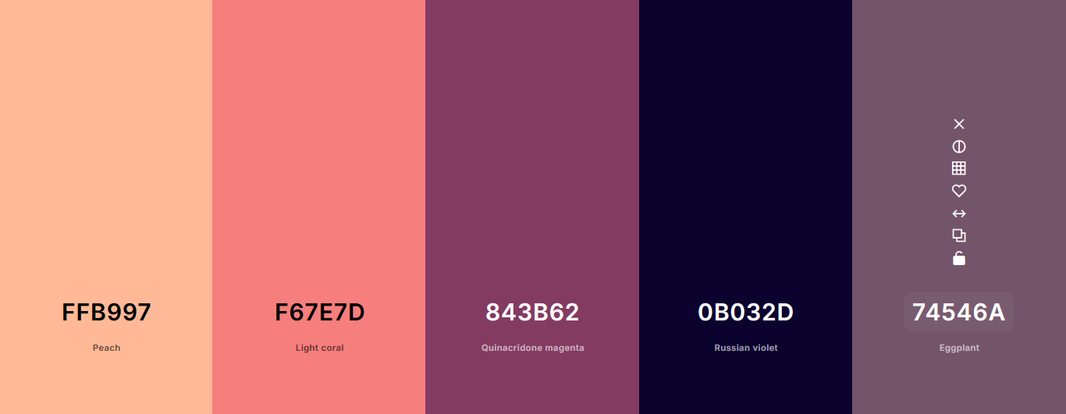

primary-color: #f67e7d

secondary-color #74546a

accent1-color: #ffb997

accent2-color: #843b62

accent3-color: #0b032d

**Typography**

Headings: Noto Sans Medium 500

Body: Roboto Light 300, Roboto Regular 400